Screenshot evidences
- Requirement Analysis &amp; Planning

1.User Management

o Create users Alice and Bob.

o Assign roles and responsibilities.

Group Management

o Create Project Team Group.

o Add Alice and Bob as members.

Role Definition

o Create Project Manager and Team Member roles.

o Assign roles to users.

Table Configuration

o Create Project Table and Task Table 2.

o Define columns for tasks and projects.

5. Application Access

o Configure modules for tables.

o Assign roles for controlled access.

6. Access Control Lists (ACLs)

o Restrict Bob’s edit rights to task fields (status, comments).

o Ensure Alice has full access.

7. Workflow Automation (Flow Designer)

o Automate task assignment, status updates, and approvals.

o Notify Alice when Bob completes tasks.
- Core Platform Setup (Users, Groups, Roles)
- Creation of Users
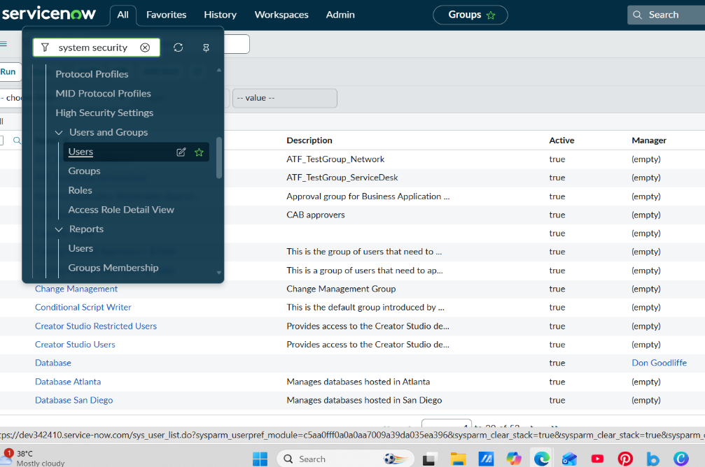

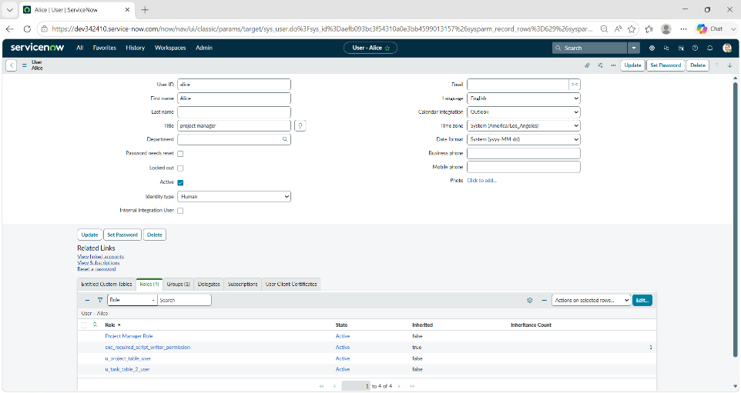

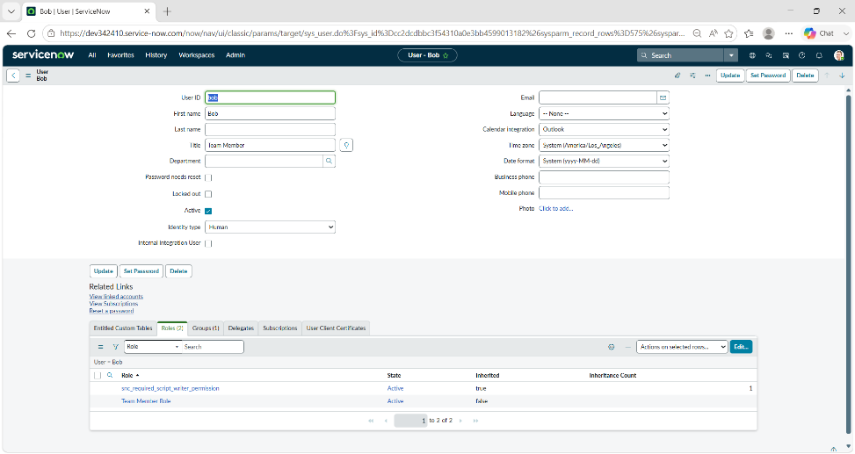
- Creation of Groups

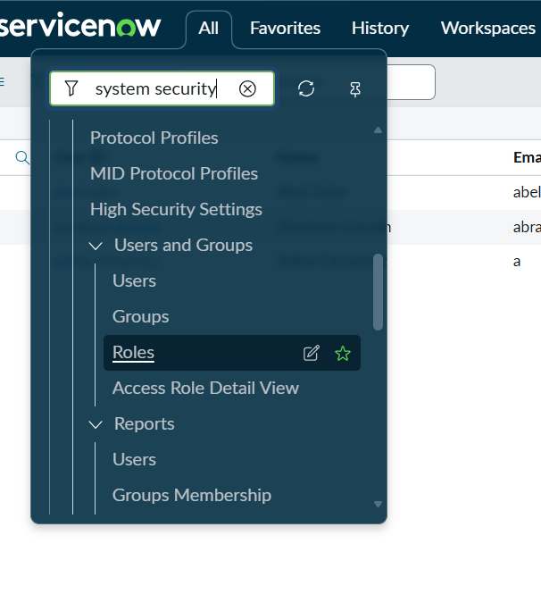
- Creation of Roles

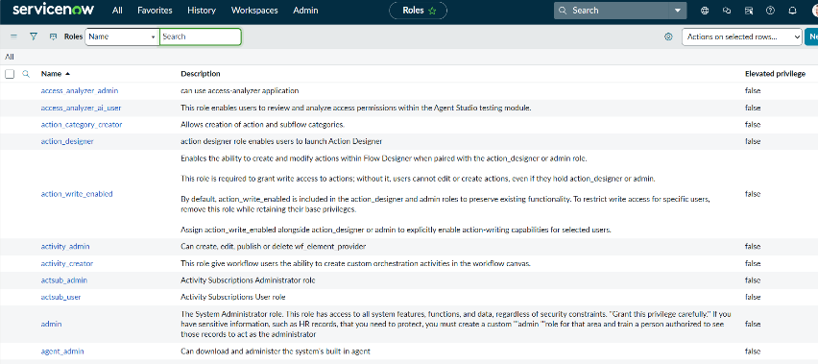
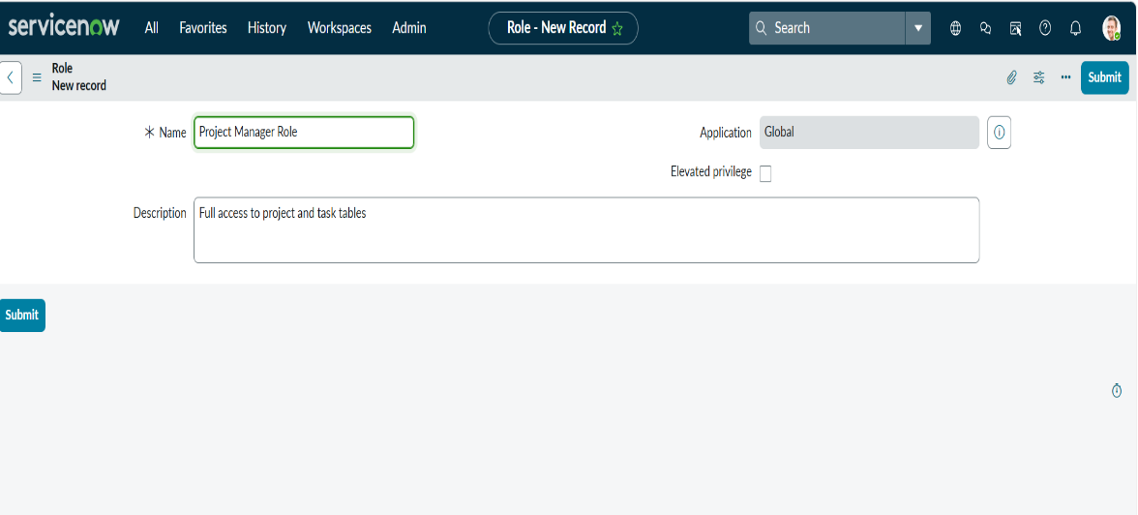
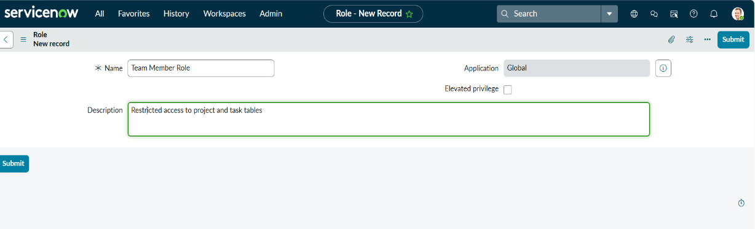
- Data & Structural Configuration
- Create Project Table

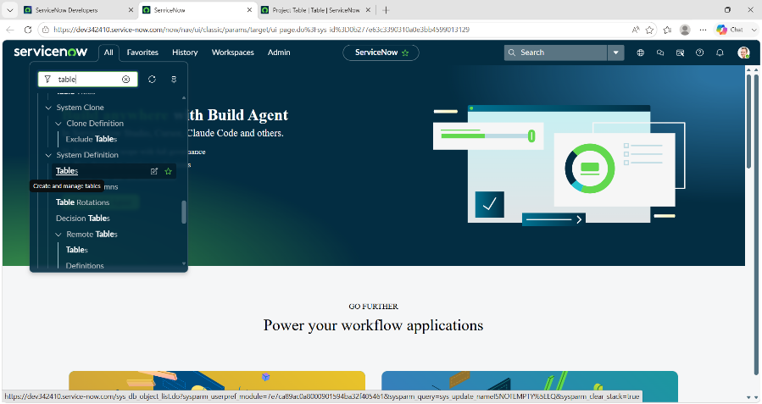

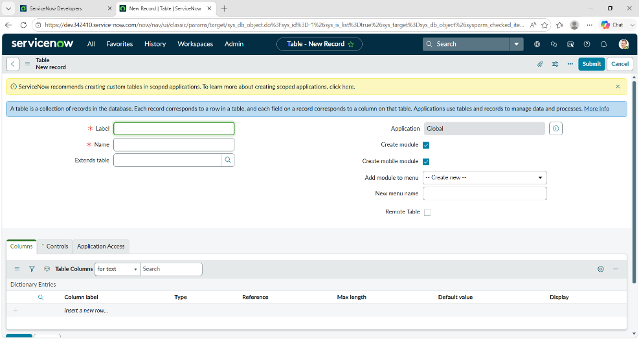

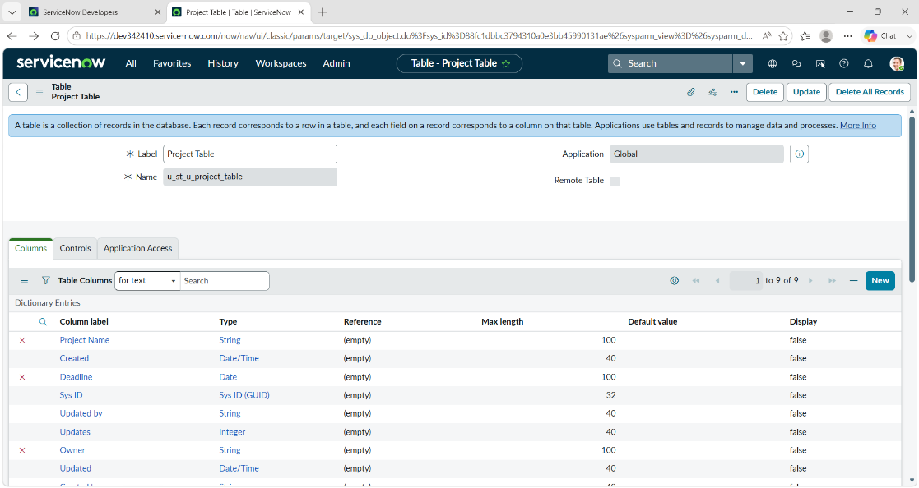
- Create Task Table 2

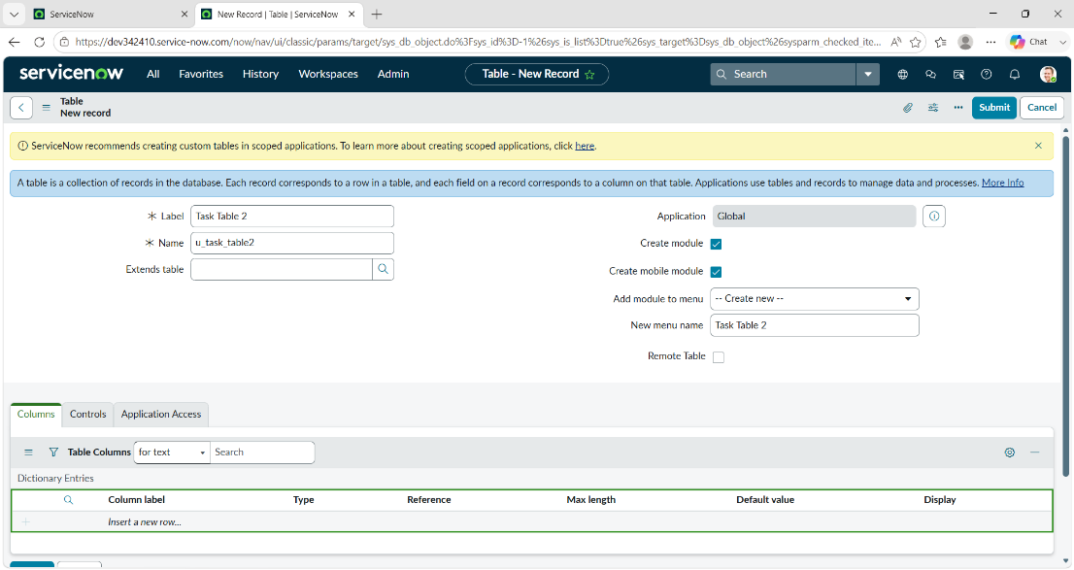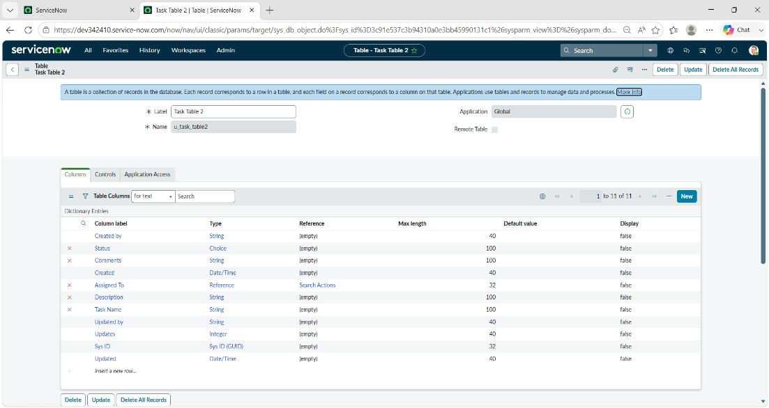
- Access Assignment & Governance Enablement
- Assign Roles to Alice (Project Manager)

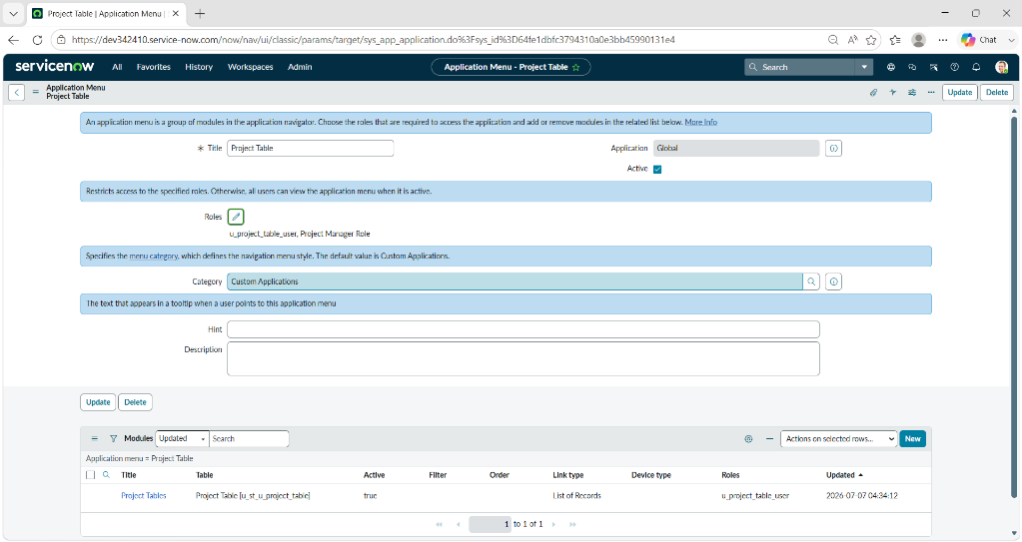
- Assign Roles to Bob (Team Member)

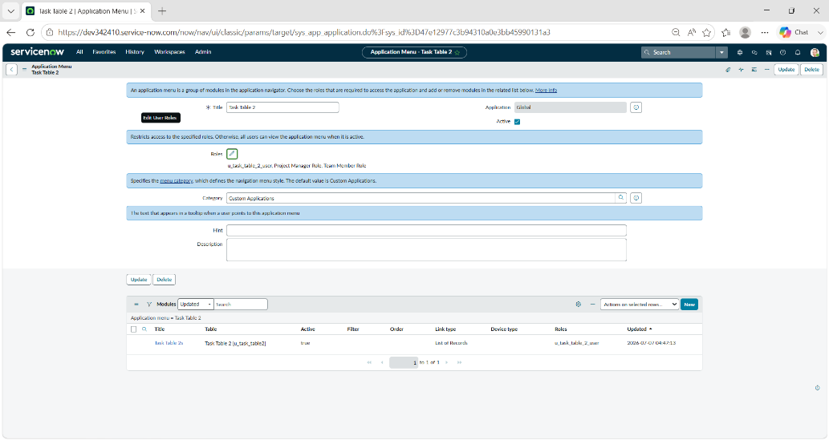
- Application Security & Access Enforcement
- Assign Table Access to Application

- Create ACLs for Task Table 2

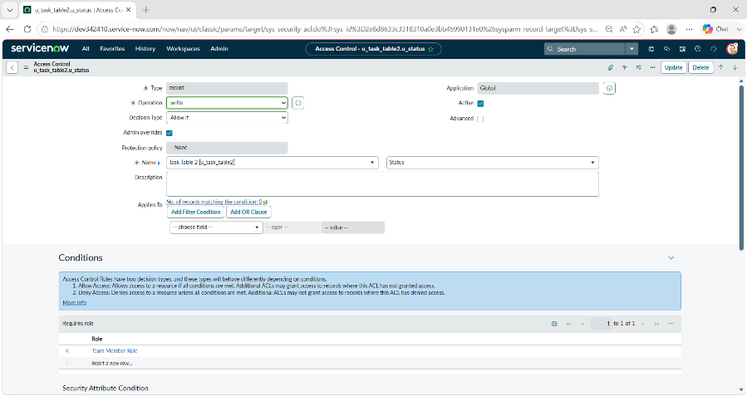
- Automation & Workflow Optimization

Create a Flow to Assign Operations Ticket to Group

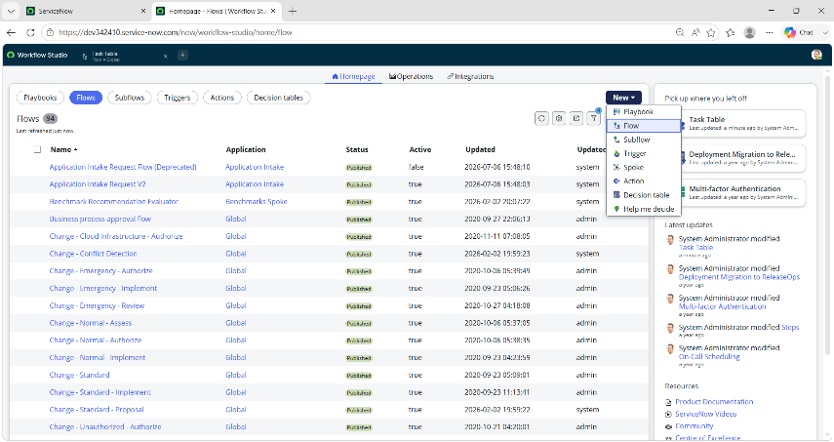
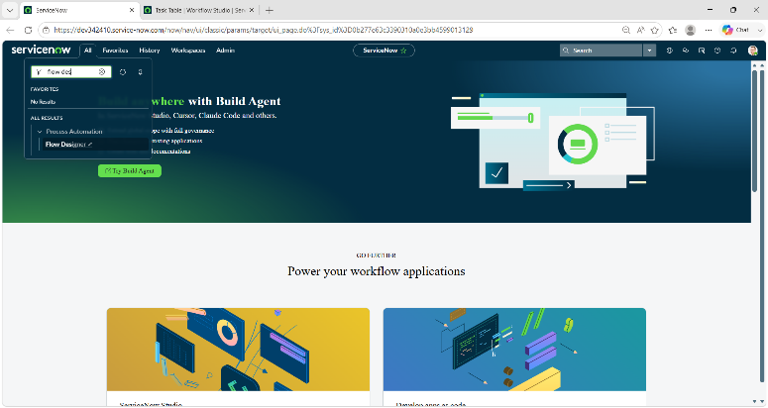
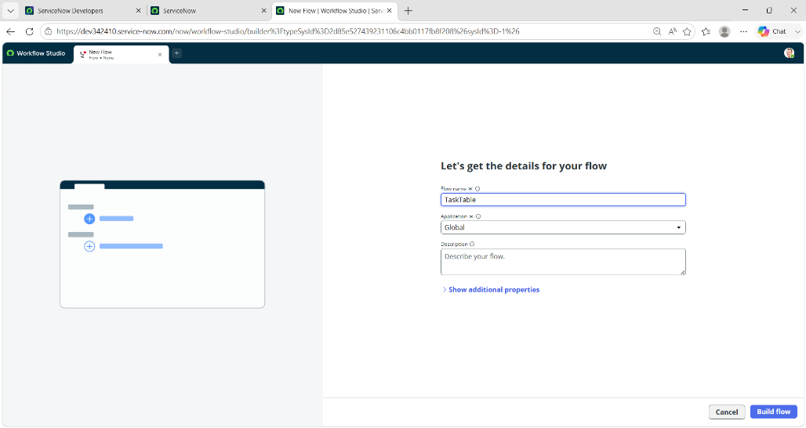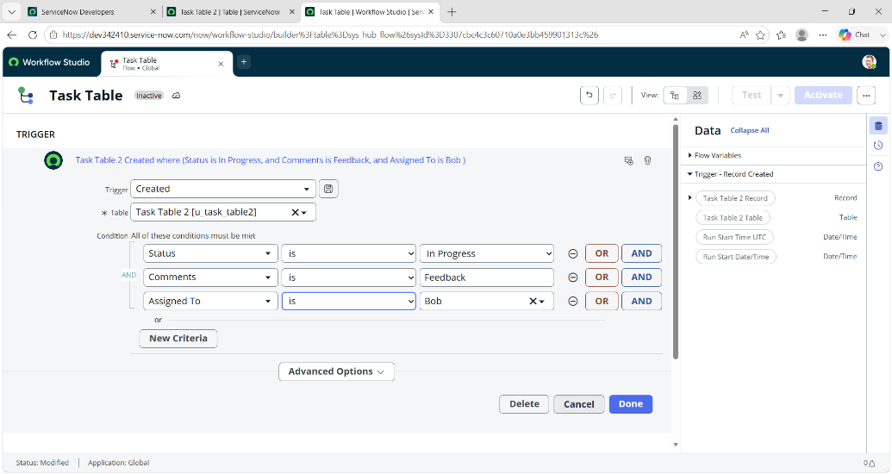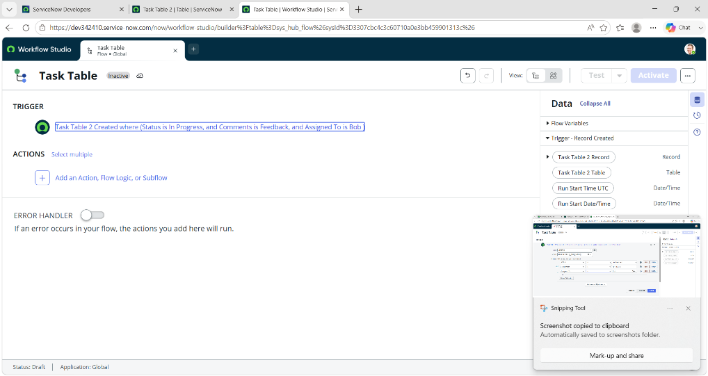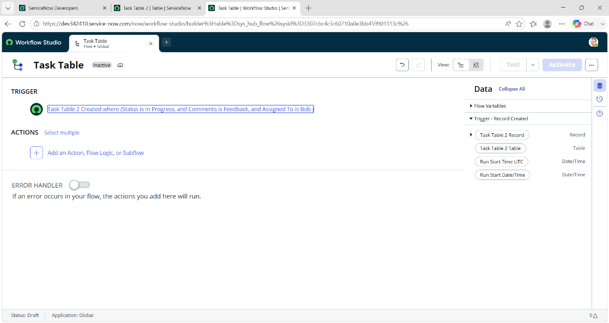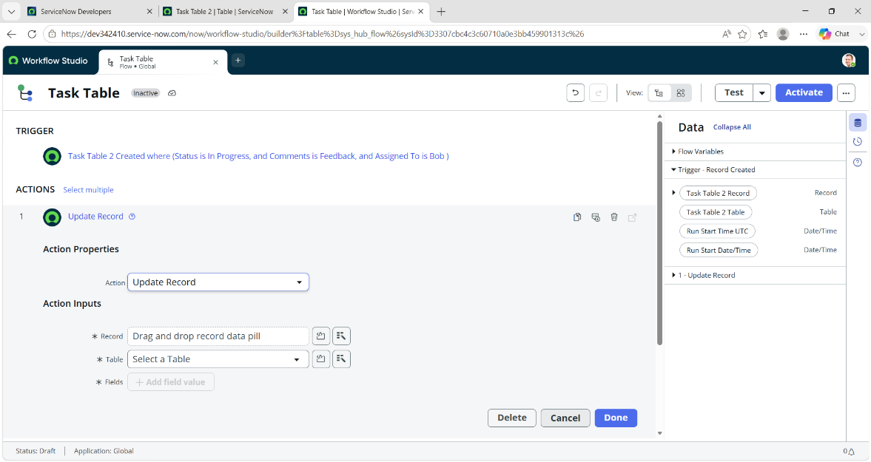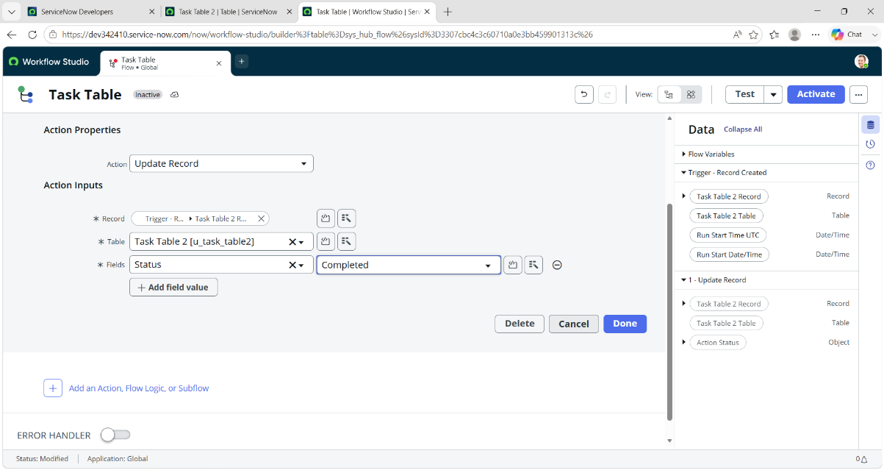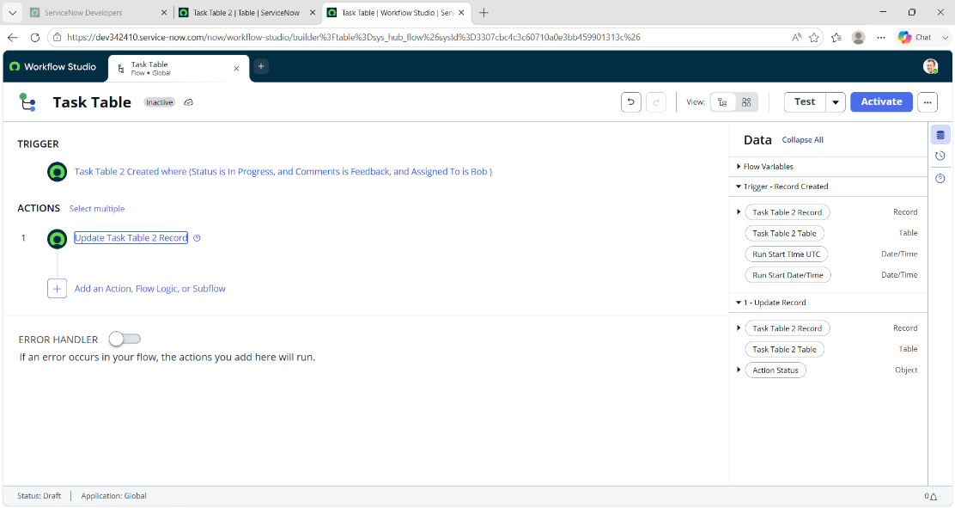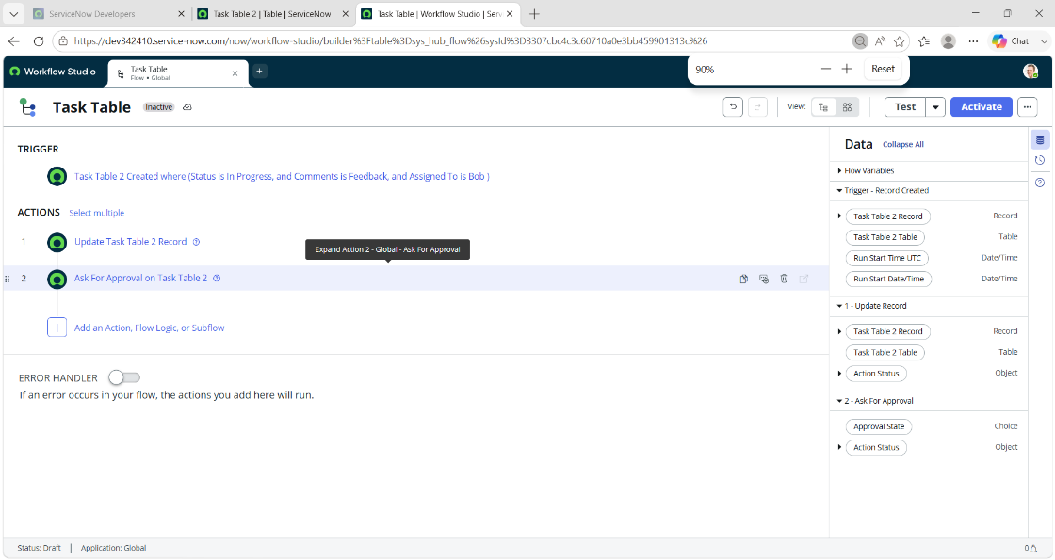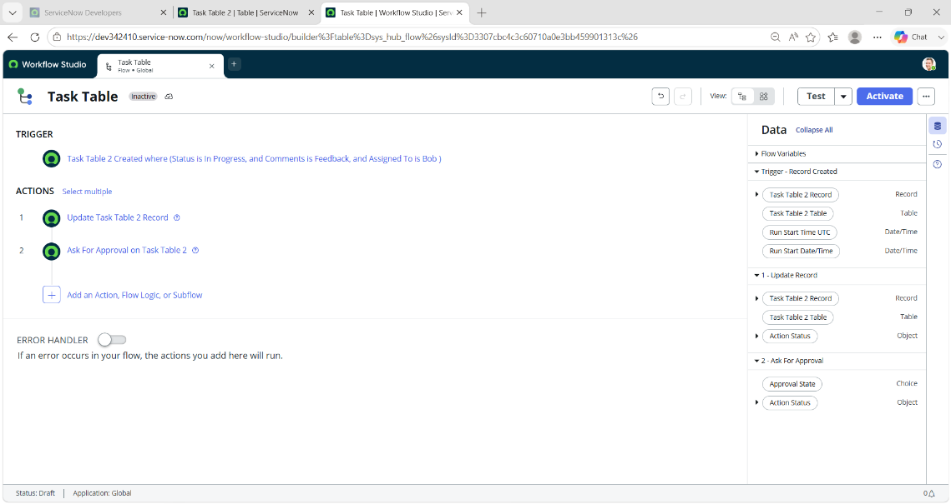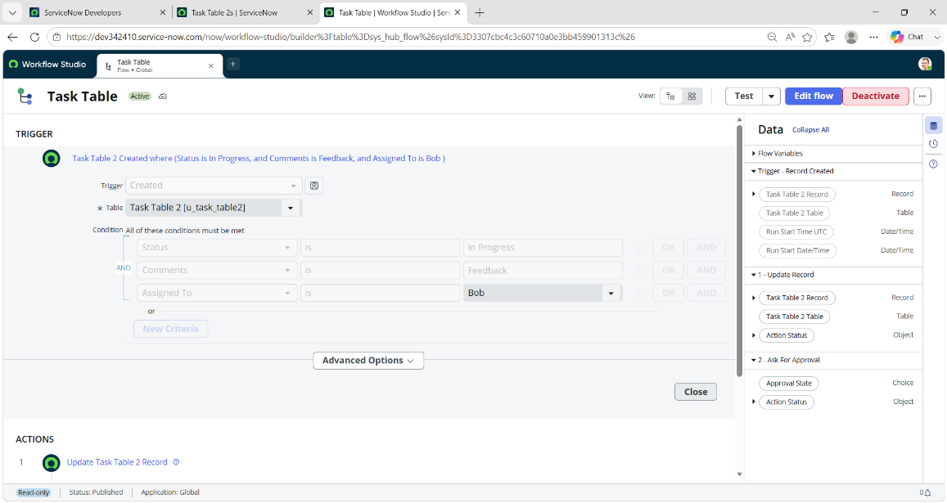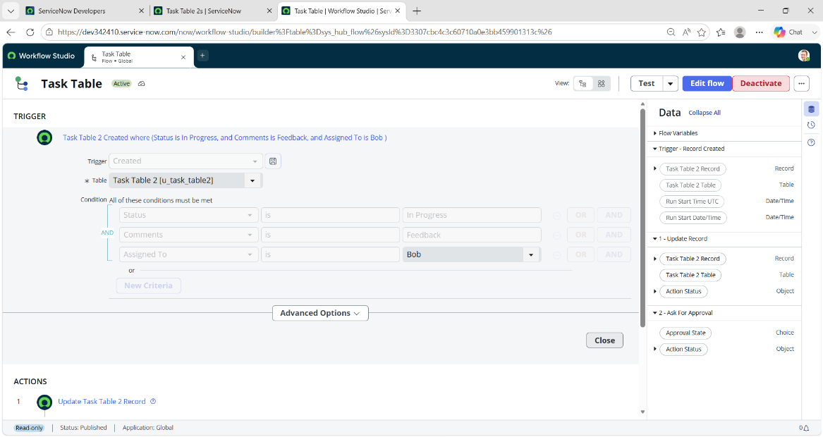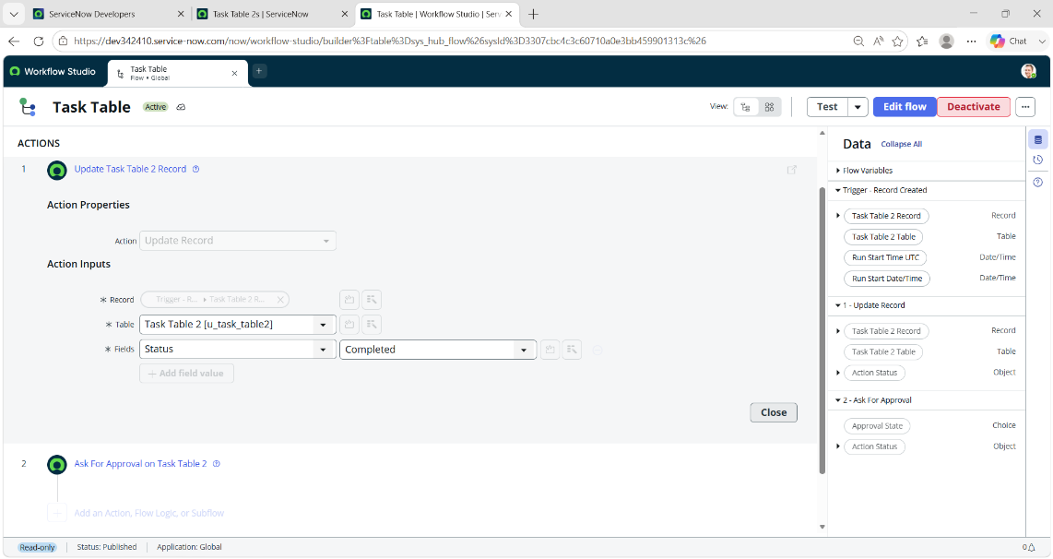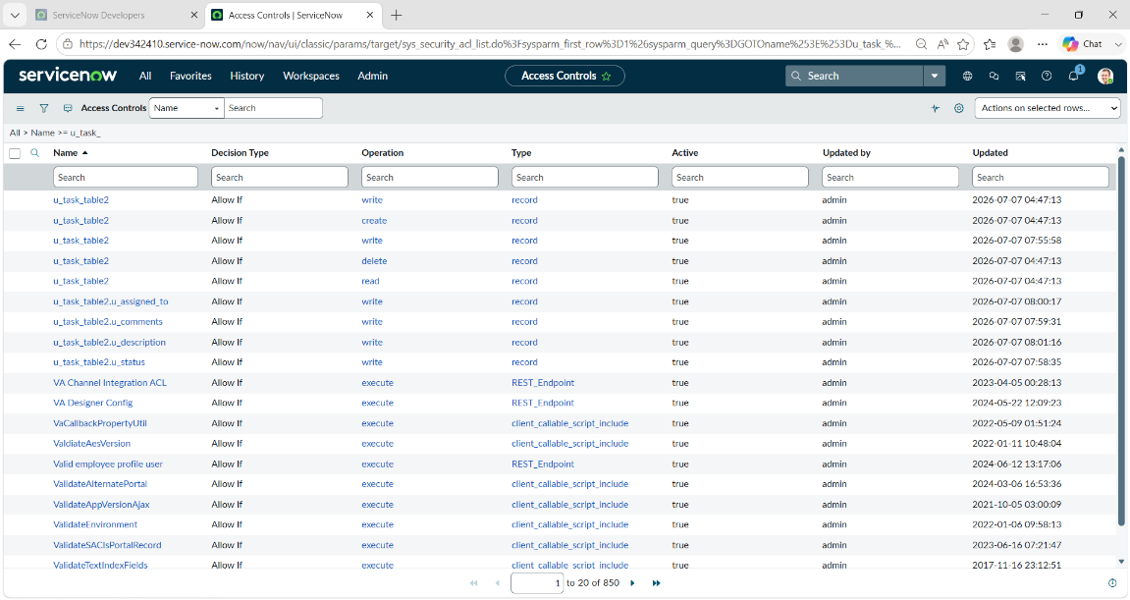
- Testing & Validation

Workflow Execution Testing

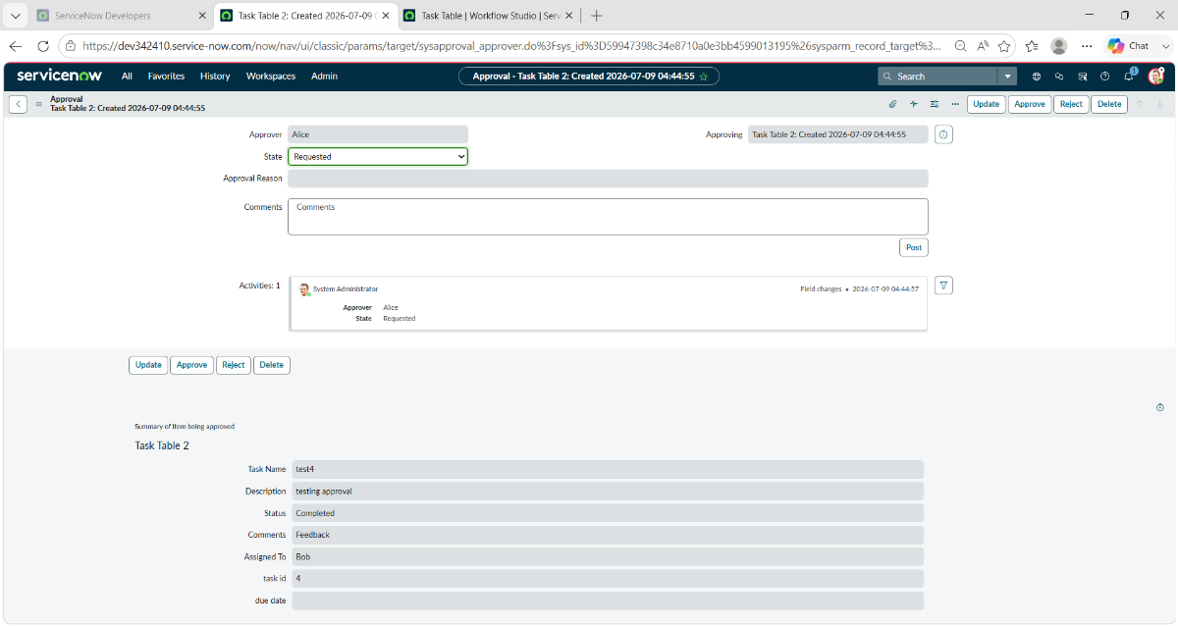

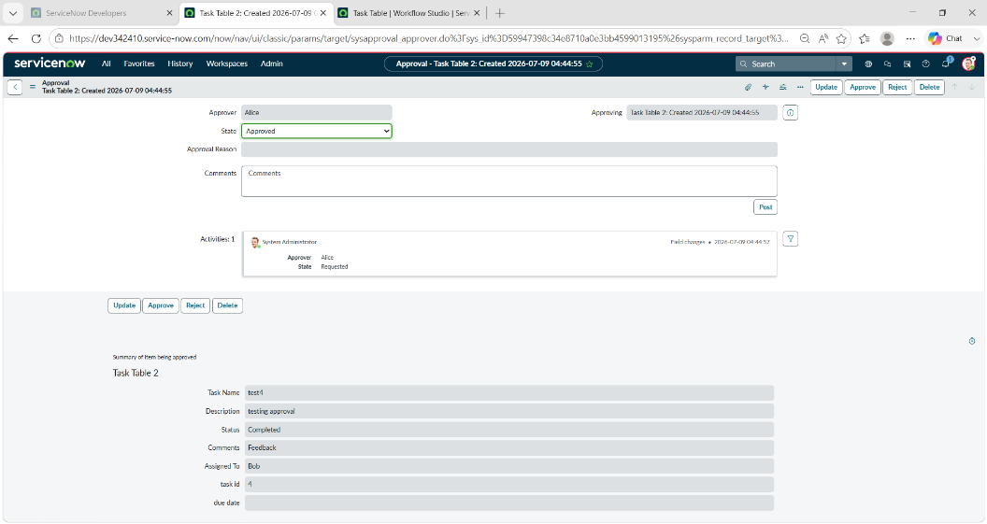
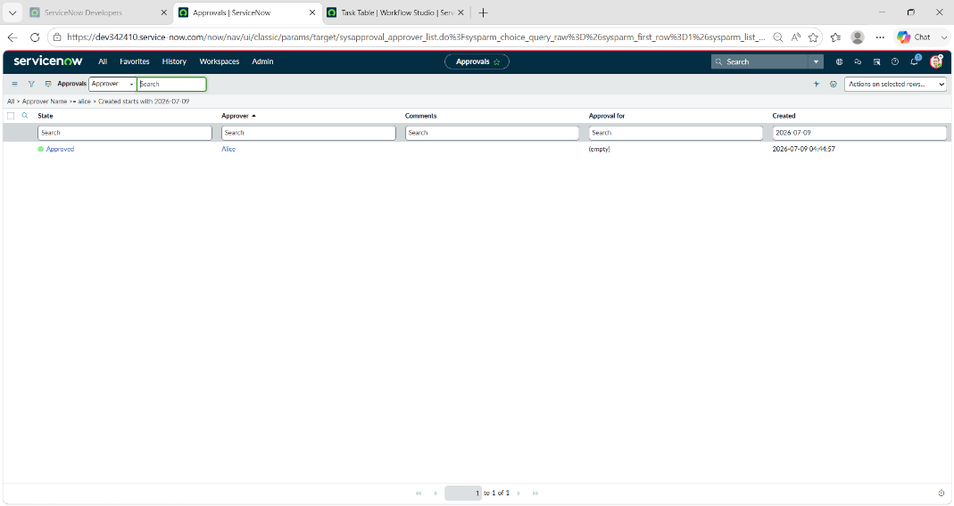
- Project Conclusion

The implementation demonstrates an organized project management setup with clearly defined roles and workflow-driven task execution. Structured tables enable efficient tracking of projects, tasks, and progress, while controlled access ensures accountability and smooth collaboration. This approach supports clear communication and contributes to successful project delivery.

